**Headline:** In Defense of Section 106 of the National Historic Preservation Act

By Jeffrey H. Altschul

**Author Bio:** Jeffrey H. Altschul is the co-president of the [Coalition for Archaeological Synthesis](https://www.archsynth.org/about/).

**Source:** Human Bridges

**Credit Line:** *This article was produced by* [*Human Bridges*](https://observatory.wiki/Human_Bridges)*.*

**Tags:** History, Social Science, North America/United States of America, Opinion

**[Article Body:]**

Section 106 of the National Historic Preservation Act is under attack. It’s not the first time. The rationale for these attacks has remained the same for the last 50 years: Section 106 compliance is slow, expensive, and unpredictable; it hinders economic growth and kills jobs. All of this comes easy to its detractors; none of it is true.

Section 106 requires federal agencies to assess the effects of their actions that involve lands they administer, permits they provide, and licenses they grant on historic, archaeological, and cultural properties listed in or eligible to be listed in the National Register of Historic Places, and, to the extent possible, minimize harmful effects to these significant places. The rules governing Section 106 have been in place since 1974. The path toward compliance is well-worn and easy to follow. So why the attacks?

**Who Cares?**

Before we get into the nitty-gritty of the fight over Section 106, let’s start with three broader questions: Do Americans care about preserving their history? Do Americans want historic places protected and preserved? Do Americans want taxpayer money spent on historic preservation? The best answers to these questions come from polls taken over the last 25 years (Ipsos [2018](https://ecommerce.saa.org/common/uploaded%20files/saadocs/PublicOutreach/ipsos_poll2018.pdf), [2023](https://ecommerce.saa.org/common/uploaded%20files/saadocs/PublicOutreach/ipsos2023_report.pdf); [Ramos and Duganne](https://ecommerce.saa.org/common/uploaded%20files/saadocs/PublicOutreach/harris_poll1999.pdf) 2000; [Shannon](https://static1.squarespace.com/static/64fef3a435ce4611b96f4758/t/65a675635a0d16143bb21083/1705407843683/Summary-of-A-Survey-of-the-Public-Sandra-Shannon-FINAL.pdf) 2014). Consistently, between 80 percent and 90 percent of respondents state that archaeological sites and historic buildings are important to them. In the latest poll ([Ipsos 2023](https://ecommerce.saa.org/common/uploaded%20files/saadocs/PublicOutreach/ipsos2023_report.pdf)), 64 percent responded that archaeological site preservation should be a priority of the federal government, with 77 percent replying that there should be laws to protect archaeological sites and only 5 percent desiring no laws. Most respondents want federal funding for the protection of sites to increase and 80 percent want more land associated with archaeological sites to be set aside and preserved.

It’s one thing to answer a poll, it’s another to act on those beliefs. “So, what do Americans do on their vacations and how do they spend their money?” For many, the answer is visiting archaeological and historic sites. For example, since it opened in 1908, Mesa Verde National Park has hosted about 37 million visitors, with an average of more than 500,000 annually for the last 60 years. Gettysburg National Military Park was established in 1934 and has been visited by more than 136 million visitors, with an average attendance for the last 65 years cresting more than 1 million annually.

Perhaps surprising to some, one of the most visited National Historic Parks (NHP) is the San Antonio Missions, which since 1983 has preserved four of the five Spanish Missions near San Antonio (the fifth, the Alamo, is the best known and most visited but is not part of the park and not included in the visitation numbers). The San Antonio Missions NHP has been visited by more than 42 million people, easily exceeding an average of 1 million visitors a year since its inception.

But it’s not just the most famous parks that receive visitors. In my home state of Arizona, there are 19 national parks (NP), monuments, historic sites, and memorials administered by the National Park Service (NPS) (Table 1). Of these, 11 are national monuments, historic sites, or memorials (collectively, termed “NM” below) focused around archaeological or historic sites. In 2024, more than 1.6 million people visited these 11 NMs (NPS 2025), spending about $167 million and accounting for about 1,650 jobs ([Flyr and Koontz 2024](https://irma.nps.gov/DataStore/Reference/Profile/2305351)). In all, the archaeological and historical NMs account for about 20 percent of all NPS visitation in Arizona and more than 10 percent of the money spent and jobs created at NPS units in the state.

One of the parks in Arizona is the Grand Canyon, which by itself accounts for more than half of all visits, money, and jobs to Arizona NPS units. If we exclude the Grand Canyon National Park, then archaeological and historical NMs are responsible for about 45 percent of all visitations, money, and jobs at NPs and NMs in Arizona. Some may scoff at the size of the numbers, but it’s important to remember that many archaeological and historic NMs are in rural parts of the state, where the dollars generated and the jobs created at these units are extremely important to local businesses and communities. Also, some of the archaeological and historical NMs are hard to get to (for example, you need to hike a 3-mile loop to get in and out of Fort Bowie).

No matter how difficult, Americans keep coming. With their money and their time, Americans overwhelmingly declare that they enjoy visiting and learning about the past at archaeological and historical sites. They come alone, with their families, their friends, their schools, and their churches. They are awed by what Americans have done and are inspired to dream about things they might do.

**Back to Section 106**

Section 106 seeks to balance the interests of project proponents and land developers with protecting the historic fabric of this country. Those who contend that Section 106 is an impediment to development tend to be those with an economic interest. They provide anecdotal evidence of particular projects in which Section 106 compliance was maddeningly slow and outrageously expensive. They never, however, analyze Section 106 actions in a systematic and comprehensive manner, since such an evaluation shows a very different story.

Table 2 is derived from a report on the cumulative impact of the Historic Preservation Fund for the period 2001-2021, commissioned by the National Conference of State Historic Preservation Officers ([PlaceEconomics 2023:22](https://www.placeeconomics.com/resources/the-cumulative-impact-of-the-historic-preservation-fund/)). It shows that for the first two decades of the 21st century, the State Historic Preservation Office (SHPO) in 59 jurisdictions made about 4.3 million decisions

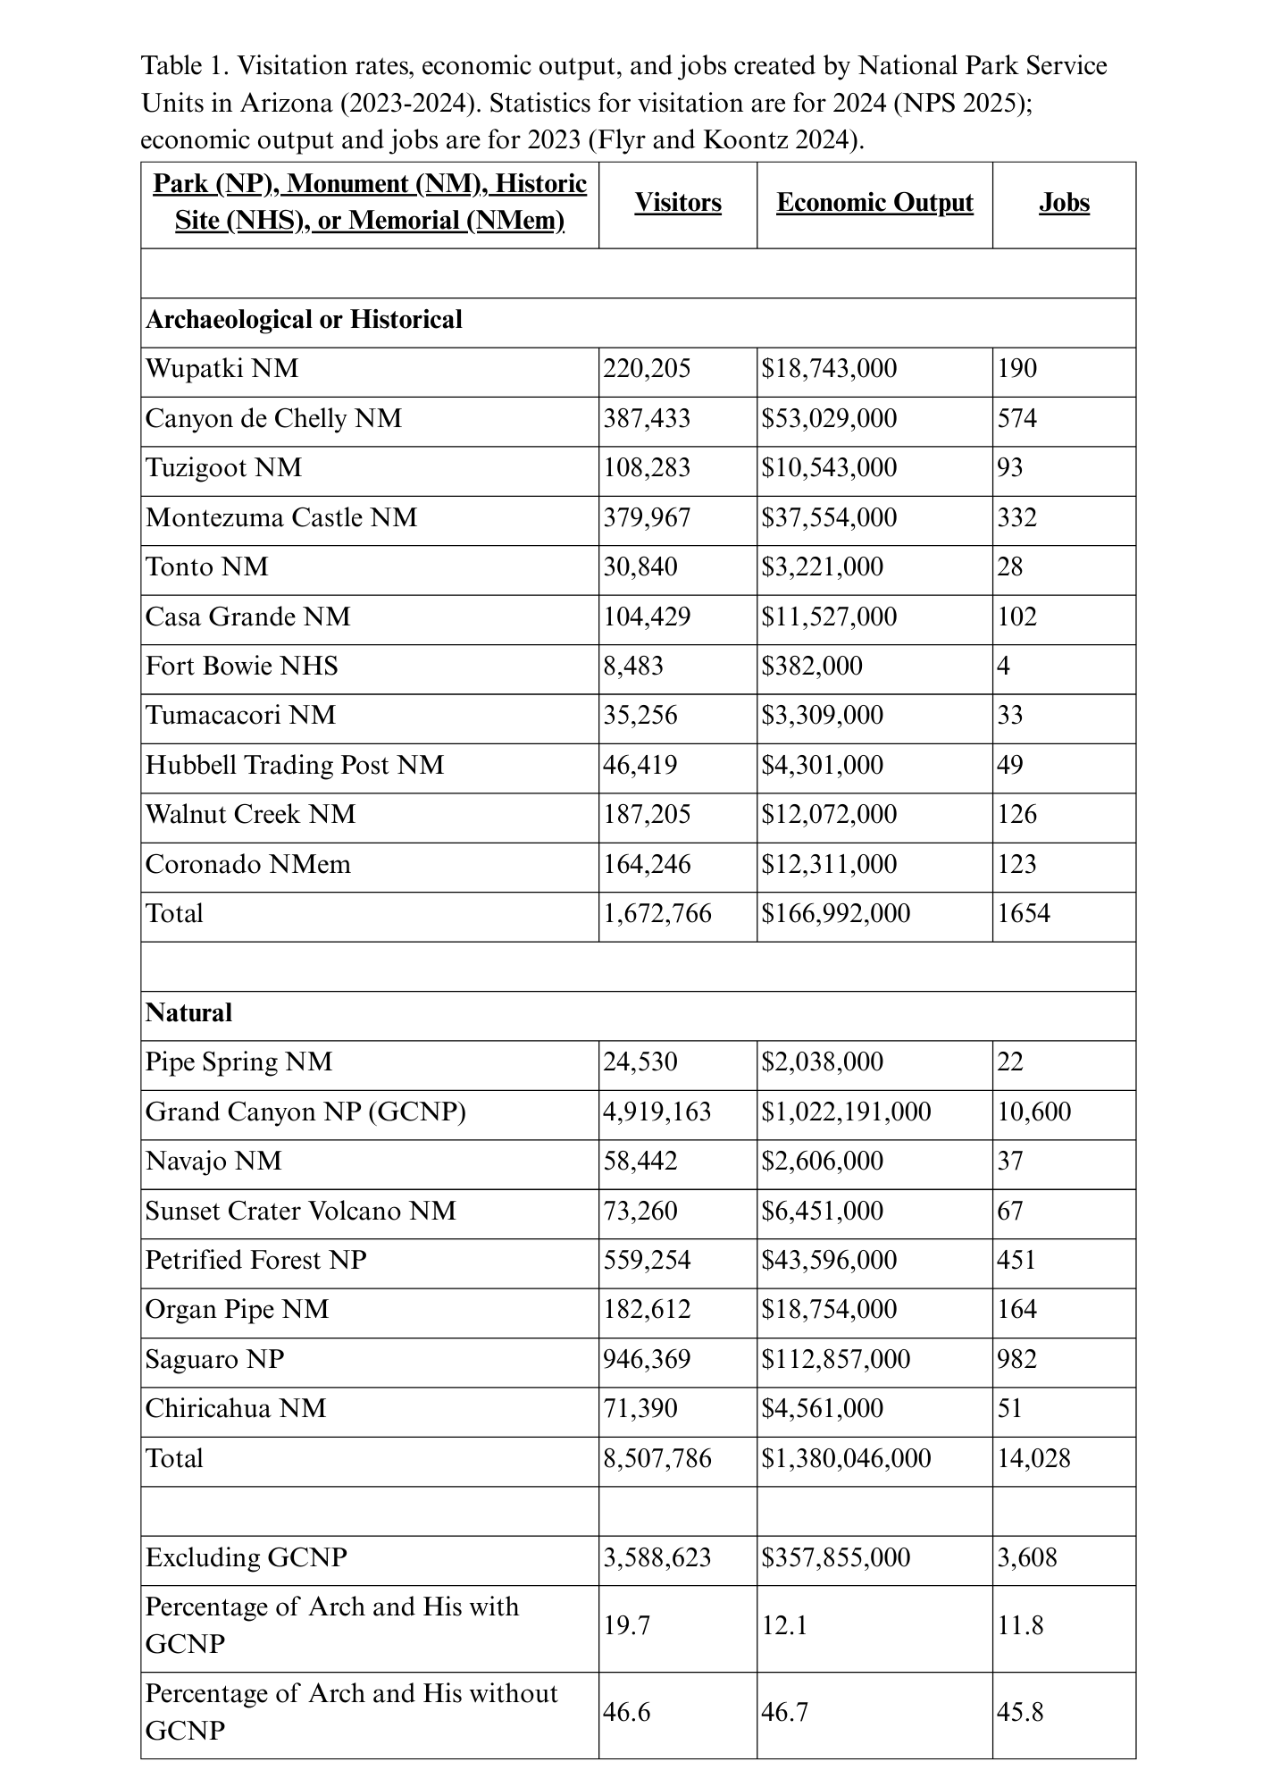

related to Section 106 undertakings. Nearly 80 percent of these decisions were findings that either no historic properties were found in the project area or that those that did exist were not sufficiently significant to warrant any action. In short, about 3.4 million projects brought before SHPOs were dealt with quickly and cheaply, with the project proponent or

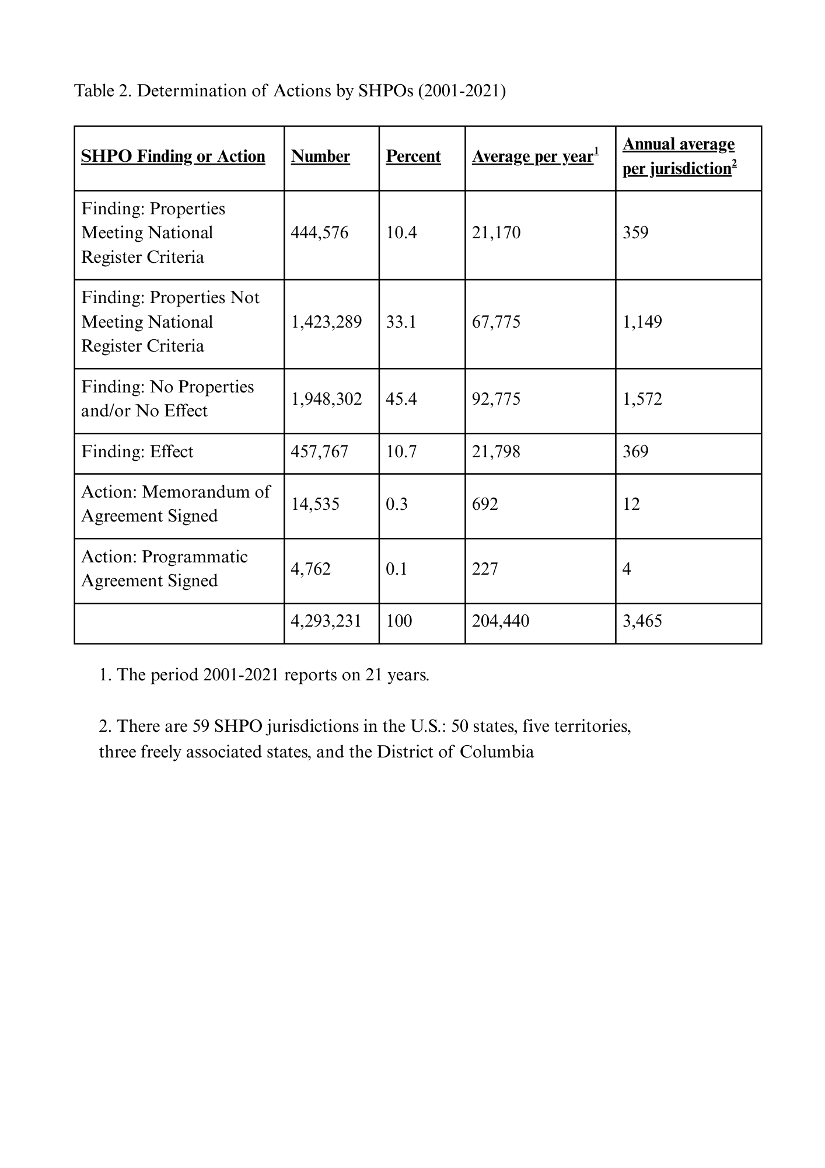

developer free to proceed in less than 30 days (often in less than a week). In addition, many federal agencies, in partnership with SHPOs and other consulting parties, have made agreements that exclude a vast number of small-scale projects from Section 106 reviews, which have minimal potential to adversely affect the National Register listed or eligible properties. These Section 106 agreements are effective tools that streamline and expedite a wide range of development projects.

About 900,000 projects were found to include a significant property and/or have an adverse effect on such a property. Most of these were altered, redesigned, or withdrawn so that the historic property or properties were not harmed and the proponent was free to proceed or move on to another project without having spent lots of money or wasted considerable time. Of the millions of Section 106 undertakings, **less than 0.5%** resulted in an agreement document among the SHPO, federal agency, affected Native American tribes, project proponent, local jurisdictions and communities, and other interested public groups on how to resolve the project’s harmful effects on significant historic properties. In 21 years, less than 20,000 agreement documents were signed in the 59 SHPO jurisdictions, or **less than 20 per year in the entire country**. What do these 20 projects have in common? They contained properties of historical and cultural value to our nation, local communities, Native American tribes, and descendants. The Section 106 agreement documents protected the values embedded in those places while allowing development to proceed.

**Safeguard or Obstruction**

There are two views of Section 106. Many in the development community view it as a regulation that inhibits economic progress. They argue that the Section 106 process is used by opponents to stymie or kill projects, particularly large and controversial ones. In contrast, local and descendant communities maintain that Section 106 provides them with one of the few means by which they have any say in development decisions. Even with Section 106, however, these groups maintain that the playing field is unequal, with development holding the stronger hand.

Each view has some truth to it, and each overstates the harm that regulations cause them. I have been involved with more than 1,000 Section 106 projects in the last 50 years. The vast majority were uncontested and noncontroversial. The results documented the past, protected significant places, and expedited economic development. There were also a handful of controversial projects, in which passions became inflamed, the proponents and opponents talked past each other, and the agreement reached was in name only, with both sides feeling that they had been shorted.

Critics of Section 106 point to these controversial projects as evidence that the regulation doesn’t work, that it neither protects significant places nor allows the country to build needed infrastructure or improve property. Yet this view is wrong on the facts and mistaken in where it places the blame. Section 106 is a procedural law that does not establish a required outcome. The federal agency with jurisdiction over a project has the final decision, which in almost every case is to allow the project to proceed.

As a country, we want economic development that betters our lives and strengthens our communities. Development that offers a brighter future must be grounded in our shared past. Killing Section 106 would do nothing to further our aspiration to balance economic development with historic preservation. It would not even speed up development. Instead, it would ensure that historic preservationists, who otherwise welcome the opportunity to work with developers, would become entrenched opponents. Heritage strikes at the heart of a community’s ethos, so few land battles stir more passion. Section 106 negotiations can be intense, irate, and irreconcilable, but they take place within a structure designed to make sure everyone is heard and all viewpoints considered. With it, even the most controversial projects move forward. Without it, battle lines form at development sites with no one emerging unscathed.

Let me be clear, development projects proceed not in spite of but because of Section 106. Without the Section 106 regulations, local and descendant communities would have no voice to ensure that development is in keeping with their values and their past. Their only recourse would be to sue. Litigation would be everything critics say about Section 106 and then some—excruciatingly slow, extremely expensive, and unpredictable.

**We Can Still Do Big Things**

In 1999, Statistical Research, Inc. (SRI), the cultural resource management consulting firm my wife and I founded, was awarded a five-year contract to provide historic preservation services on the U.S. Air Force portion of the Barry M. Goldwater Range (BMGR). Located in the region of Southwest Arizona known as the Papaguería, the main military mission of the BMGR is to train fighter pilots. At the time when we were awarded the contract, the commanding officer took me aside and quietly, but firmly, said, “You’re free to do all the research and studies you want as long as the fighters continue to fly. The day that archaeology stops one flight will be your last day on the BMGR.”

Today, SRI continues to provide CRM services on the BMGR. In more than 25 years, not a plane has been grounded; not a flight has been aborted; not a mission has been altered because of archaeology. Hundreds of thousands of acres have been inventoried, thousands of archaeological sites have been recorded, hundreds of test excavations have been conducted, and several large-scale excavations have been completed. Native Americans from multiple tribes have joined archaeologists and the U.S. Air Force personnel on scores of site tours. Tribes have inventoried the BMGR for traditional properties and sacred sites, and with almost no exception, these areas have been avoided by military training. More than a bookshelf of technical reports have been written and thousands of artifacts cleaned, analyzed, and stored. Articles, books, and lectures for professional and non-professional audiences have been written or presented.

There are those on the right and the left who argue that we can’t do big things in this country. That Section 106 is choking off growth. But thousands of fighter pilots, many of whom went off to war to defend this country, were trained without interruption, while below, archaeologists and Native Americans worked together to document thousands of years of human occupation of the Papaguería.

There are those who will grant that the process works but still argue that the archaeology and history of places like the Papaguería are not critical to the history of the United States. The BMGR lies in one of the hottest, driest deserts in the United States. Who in their right mind would live here? And, really, who cares?

One hot summer day, in exasperation, I asked these very same questions. Accompanying me in the field that day was Joe Joaquin, an elder of the Tohono O’odham Nation as well as a Marine veteran of Korea and Vietnam. Joe looked around and then, with a wry grin, looked at me, “Who wouldn’t want to live here?” And then more seriously he went on, “These mountains hold our stories, the valleys [are] our ancestral sites, as O’odham people, we are put on this earth to take care of them, and without them we lose who we are. You have the skills and knowledge to find these places, which we don’t have. What you do is important.”

Joe has long since passed away, though his words still reverberate in me. Training fighter pilots is paramount to the defense of this country. But we can do that and still honor an obligation to the first people of the land. The path to doing so is clear. It’s called Section 106.

**References**

* Flyr, M., and Koontz, L. (2024). “[2023 National Park Visitor Spending Effects: Economic Contributions to Local Communities, States, and the Nation](https://irma.nps.gov/DataStore/Reference/Profile/2305351).” Science Report NPS/SR-2024/174. National Park Service, Fort Collins, Colorado.
* Ipsos (2018). “[American Perceptions of Archaeology](https://ecommerce.saa.org/common/uploaded%20files/saadocs/PublicOutreach/ipsos_poll2018.pdf).” Report commissioned by the Society for American Archaeology.
* Ipsos (2023). “[American Perception of Archaeology](https://ecommerce.saa.org/common/uploaded%20files/saadocs/PublicOutreach/ipsos2023_report.pdf).” Report commissioned by the Society for American Archaeology.
* National Park Service (NPS) (2025). [NPS Stats (National Park Service Visitor Use Statistics)](https://irma.nps.gov/Stats/).
* PlaceEconomics (2023). “[The Cumulative Impact of the Historic Preservation Fund](https://www.placeeconomics.com/resources/the-cumulative-impact-of-the-historic-preservation-fund/).” Report commissioned by the National Conference of State Historic Preservation Officers.
* Ramos, Maria, and Duganne, David (2000). “[Exploring Public Perceptions and Attitudes about Archaeology](https://ecommerce.saa.org/common/uploaded%20files/saadocs/PublicOutreach/harris_poll1999.pdf).” Report prepared by Harris Interactive for a coalition of professional societies and federal agencies.
* Shannon, Sandra (2014). “[A Survey of the Public: Preferences for Old and New Buildings, Attitudes about Historic Preservation, and Preservation-Related Engagement](https://static1.squarespace.com/static/64fef3a435ce4611b96f4758/t/65a675635a0d16143bb21083/1705407843683/Summary-of-A-Survey-of-the-Public-Sandra-Shannon-FINAL.pdf).” MA thesis, School of Architecture, University of Southern California, Los Angeles.